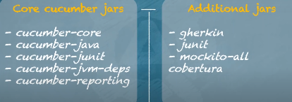

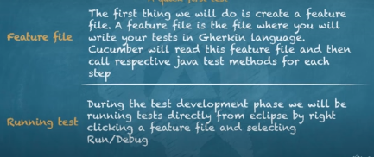

Demo 1:
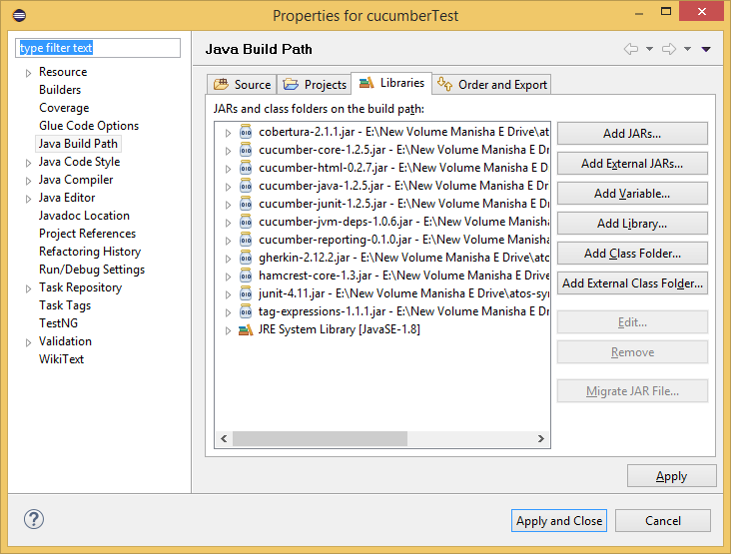

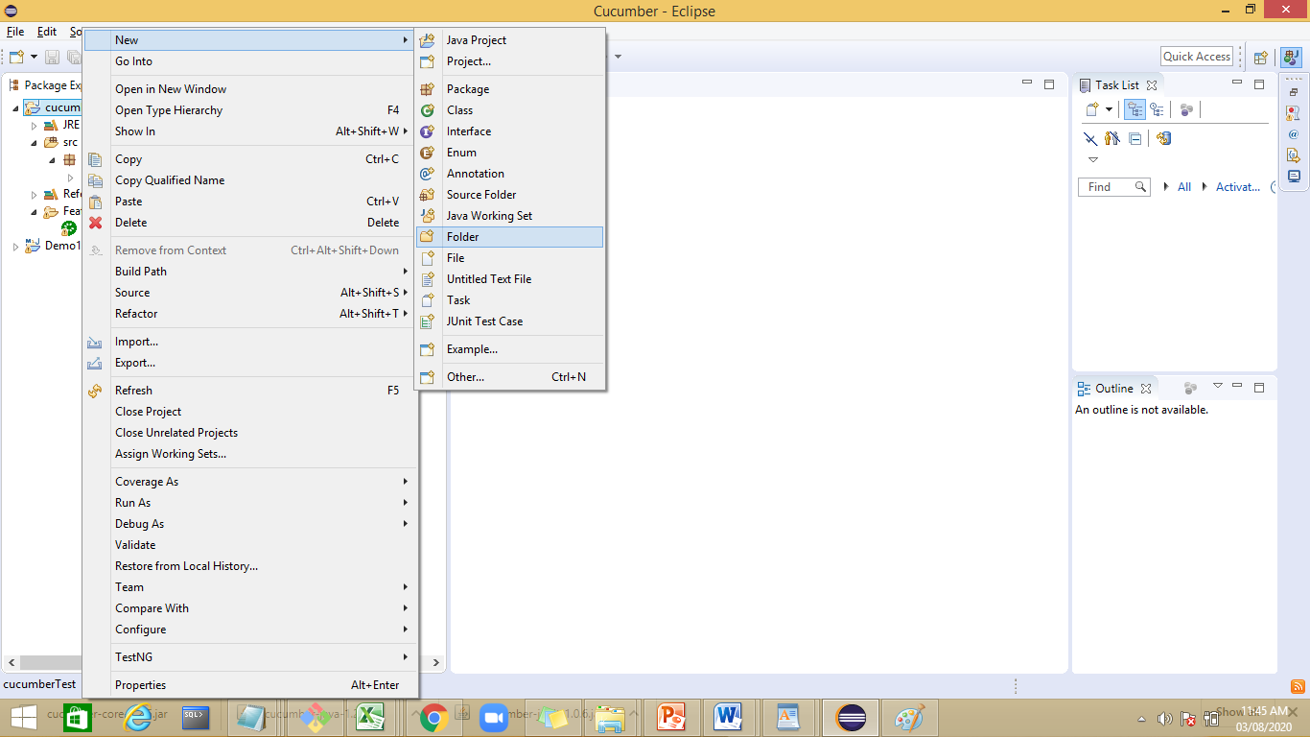
Create a folder with name Feature
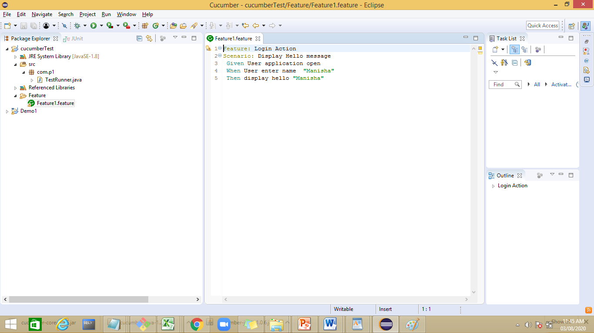
Feature: Login Action
Scenario: Display Hello message
Given User application open
When User enter name
Then display hello

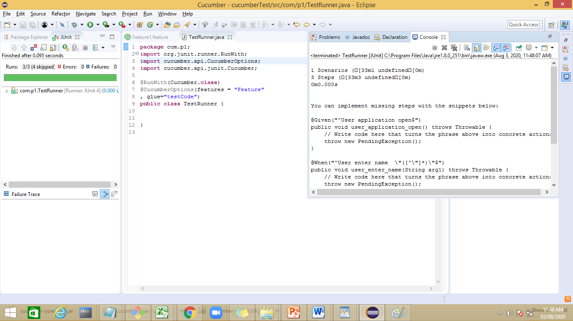
package com.p1;
import org.junit.runner.RunWith;
import cucumber.api.CucumberOptions;
import cucumber.api.junit.Cucumber;

@RunWith(Cucumber.class)
@CucumberOptions(features = "Feature"
, glue="com.step")
public class TestRunner {

}

Demo2:
Cucumber test add a step file with name HelloStep

package com.step;

import java.util.Scanner;

import cucumber.api.java.en.Given;
import cucumber.api.java.en.Then;
import cucumber.api.java.en.When;

public class HelloStep {
String name;
@Given("^User application open$")
public void User_application_open()
{
System.out.println("In user Application");
}
@When("^User enter name$")
public void User_enter_name ()
{
Scanner sr=new Scanner(System.in);
name=sr.next();
}

@Then("^display hello$")
public void display_hello()
{
System.out.println("Hello"+name);

}

}

package com.p1;
import org.junit.runner.RunWith;
import cucumber.api.CucumberOptions;
import cucumber.api.junit.Cucumber;

@RunWith(Cucumber.class)
@CucumberOptions(features = "Feature"
, glue="com.step")
public class TestRunner {

}

Output:
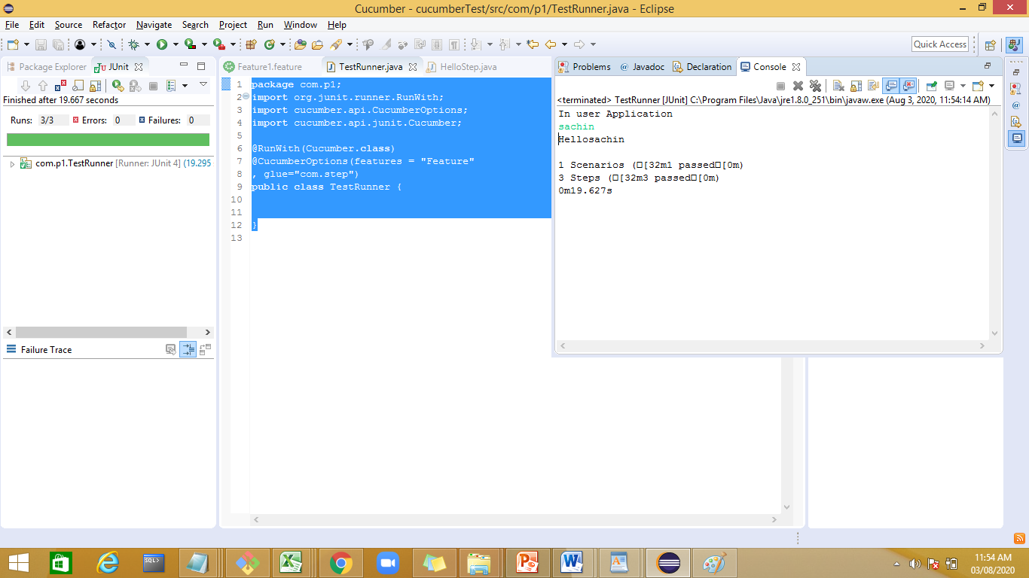

intially cover all the elements
feature with simple print
then with one scenario
then include webdriver scripts
then in cucumber options - feature, glue, reports
then tags
hooked tags with JUNIT,testNg ,maven Integeration
datadriven testing in cucumber is last topic
without example , with example .
data table

Cucumber is a testing tool that supports Behavior Driven Development (BDD). It offers a way to write tests that anybody can understand, regardless of their technical knowledge. In BDD, users (business analysts, product owners) first write scenarios or acceptance tests that describe the behavior of the system from the customer's perspective, for review and sign-off by the product owners before developers write their codes.
Cucumber is a testing tool that supports Behavior Driven Development (BDD) framework. It defines application behavior using simple English text, defined by a language called Gherkin.

Cucumber allows automation functional validation that is easily read and understood. Cucumber was initially implemented in Ruby and then extended to Java framework. Both the tools support native JUnit.

Test-Driven Development
TDD is an iterative development process. Each iteration starts with a set of tests written for a new piece of functionality. These tests are supposed to fail during the start of iteration as there will be no application code corresponding to the tests. In the next phase of the iteration, Application code is written with an intention to pass all the tests written earlier in the iteration. Once the application code is ready tests are run.

Benefits of TDD
Unit test proves that the code actually works
Can drive the design of the program
Refactoring allows improving the design of the code
Low-Level regression test suite
Test first reduce the cost of the bugs

Drawbacks of TDD
Developer can consider it as a waste of time
The test can be targeted on verification of classes and methods and not on what the code really should do
Test become part of the maintenance overhead of a project
Rewrite the test when requirements change.

Behavior Driven Development
Behavior Driven testing is an extension of TDD.
Like in TDD in BDD also we write tests first and the add application code. The major difference that we get to see here are

Tests are written in plain descriptive English type grammar
Tests are explained as behavior of application and are more user-focused
Cucumber supports different languages like Java.net and Ruby.
It allows the test script to be written without knowledge of any code, it allows the involvement of non-programmers as well.

Cucumber supports over a dozen different software platforms like -

Ruby on Rails
Selenium
PicoContainer
Spring Framework
Watir

How BDD works in Cucumber Automation?
Consider you are assigned to create Funds Transfer module in a Net Banking application.

There are multiple ways to test it
Fund Transfer should take place if there is enough balance in source account
Fund Transfer should take place if the destination a/c details are correct
Fund Transfer should take place if transaction password / rsa code / security authentication for the transaction entered by user is correct
Fund Transfer should take place even if it's a Bank Holiday
Fund Transfer should take place on a future date as set by the account holder.

In BDD, whatever you write must go into Given-When-Then steps. Lets consider the same example above in BDD

Given that a fund transfer module in net banking application has been developed
And I am accessing it with proper authentication
WhenI shall transfer with enough balance in my source account
Or I shall transfer on a Bank Holiday
Or I shall transfer on a future date
And destination a/c details are correct
And transaction password/RSA code/security authentication for the transaction is correct
And press or click send button
Then amount must be transferred
And the event will be logged in log file
What is Cucumber Feature File?
A Feature File is an entry point to the Cucumber tests. This is a file where you will describe your tests in Descriptive language (Like English). It is an essential part of Cucumber, as it serves as an automation test script as well as live documents. A feature file can contain a scenario or can contain many scenarios in a single feature file but it usually contains a list of scenarios. Let’s create one such file.

Demo1:
Download jars for
cucumber-core,cucmber-java,cucumber-junit,cucumber-

1. Create a new java project.
2. Build path and add external libra..
3.

test are written in a language called gherkin.
Feature:A Feature File is an entry point to the Cucumber tests. This is a file where you will describe your tests in Descriptive language (Like English). It is an essential part of Cucumber, as it serves as an automation test script as well as live documents. A feature file can contain a scenario or can contain many scenarios in a single feature file but it usually contains a list of scenarios

JUnit Test Runner Class
Create a new Class file in the ‘cucumberTest‘ package and name it as ‘TestRunner‘, by right click on the Package and select New > Class. This class just needs annotations to understand that cucumber features would be run through it and you can specify feature files to be picked up plus the steps package location

Here is the list of keywords that Gherkin supports:
Gherkin Keyword:

Feature
Background
Scenario
Given
When
Then
And
But
*
====================================================================
Demo 2: with maven

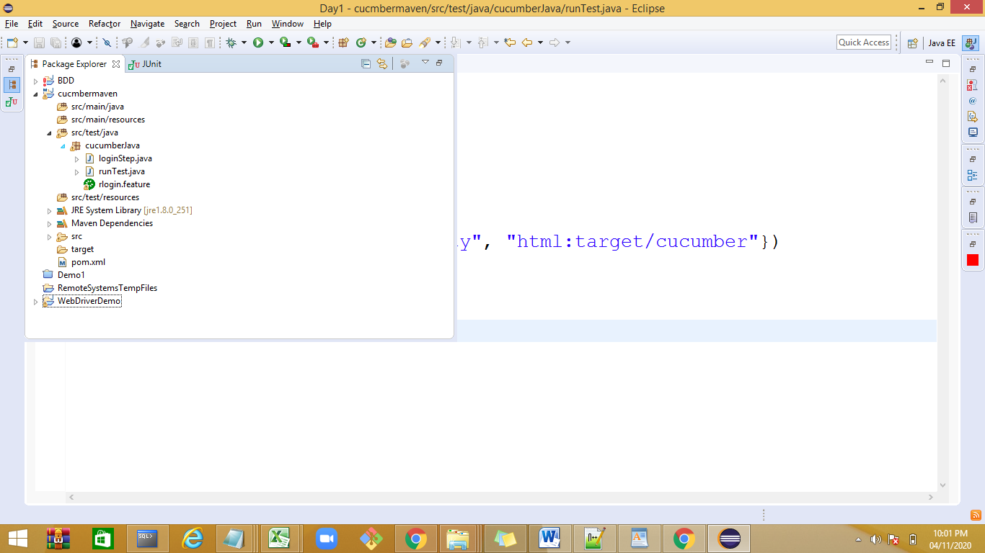

Pom.xml

<dependency>
<groupId>org.seleniumhq.selenium</groupId>
<artifactId>selenium-java</artifactId>
<version>2.47.1</version>
</dependency>

<dependency>
<groupId>info.cukes</groupId>
<artifactId>cucumber-java</artifactId>
<version>1.0.2</version>
<scope>test</scope>
</dependency>

<dependency>
<groupId>info.cukes</groupId>
<artifactId>cucumber-junit</artifactId>
<version>1.0.2</version>
<scope>test</scope>
</dependency>

<dependency>
<groupId>junit</groupId>
<artifactId>junit</artifactId>
<version>4.10</version>
<scope>test</scope>
</dependency>

====================================================

reports:

1. Pretty Report

2. Monochrome Mode Reporting

3. Usage Report

4. Cucumber Report Output

Cucumber HTML Reports

Cucumber JSON Report

Cucumber JUNIT XML Report
https://www.toolsqa.com/selenium-cucumber-framework/cucumber-reports/

Reports:
Demo 1:
@CucumberOptions( features = "src/test/resources/Features",glue="",
plugin = {"pretty", "html:target/Destination"} )

//Specifying pretty as a format option ensure that HTML report will be generated.
//When we specify html:target/Destination - It will generate the HTML report

inside the Destination folder, in the target folder of the maven project.

Demo 2:
Pretty Report
The first plugin, we will talk about is Pretty. This provides more verbose output.
To implement this, just specify plugin = “pretty” in CucumberOptions. This is what the code looks like:

@CucumberOptions( plugin = { “pretty” } )

@CucumberOptions( features = "src/test/resources/Features",glue="",
plugin = {"pretty"} )

output:
Please see https://chromedriver.chromium.org/security-considerations for suggestions on keeping ChromeDriver safe.
ChromeDriver was started successfully.
[1596513491.825][WARNING]: This version of ChromeDriver has not been tested with Chrome version 84.
ChromeDriver: chrome on XP (714324382e0e41446b9a63866bc2c045)
login page open
user enters valid user name & password
user is able to login

Scenario: Successful Login with Valid Credentials [90m# Feature1.feature:3[0m
[32mGiven [0m[32mUser is on Home Page[0m [90m# LoginStep.user_is_on_Home_Page()[0m
[32mWhen [0m[32mUser Navigate to LogIn Page,enter valid username and password[0m [90m# LoginStep.user_Navigate_to_LogIn_Page()[0m
[32mThen [0m[32mMessage displayed Login Successfully[0m [90m# LoginStep.message_displayed_Login_Successfully()[0m

1 Scenarios ([32m1 passed[0m)
3 Steps ([32m3 passed[0m)
0m10.863s

Demo 3:
Monochrome Mode Reporting
If the monochrome option is set to false, then the console output is not as readable as it should be. The output when the monochrome option is set to false is shown in the above example. It is just because, if the monochrome is not defined in Cucumber Options, it takes it as false by default. How to specify it:

@CucumberOptions( monochrome = true );

@CucumberOptions( features = "src/test/resources/Features",glue="",
plugin = {"pretty"} ,monochrome=true)

output:
Please see https://chromedriver.chromium.org/security-considerations for suggestions on keeping ChromeDriver safe.
ChromeDriver was started successfully.
[1596513616.927][WARNING]: This version of ChromeDriver has not been tested with Chrome version 84.
ChromeDriver: chrome on XP (6866b52f45e96ff249932ffdbe5deb0b)
login page open
user enters valid user name & password
user is able to login

Scenario: Successful Login with Valid Credentials # Feature1.feature:3
Given User is on Home Page # LoginStep.user_is_on_Home_Page()
When User Navigate to LogIn Page,enter valid username and password # LoginStep.user_Navigate_to_LogIn_Page()
Then Message displayed Login Successfully # LoginStep.message_displayed_Login_Successfully()

1 Scenarios (1 passed)
3 Steps (3 passed)
0m25.311s

Usage Report
If we are more concerned about the time taken by each Step Definition, then we should use the usage plugin. This is how we specify the same in @CucumberOptions:

@CucumberOptions( plugin = { “usage” })
@CucumberOptions( features = "src/test/resources/Features",glue="",
plugin = {"usage"} ,monochrome=true)

output:
ChromeDriver: chrome on XP (72bb5485ecb1a61591f6f75a66d4ac93)
login page open
user enters valid user name & password
user is able to login
[
{
"source": "^User is on Home Page$",
"steps": [
{
"name": "User is on Home Page",
"aggregatedDurations": {
"average": 7.760189601,
"median": 7.760189601
},
"durations": [
{
"duration": 7.760189601,
"location": "Feature1.feature:5"
}
]
}
]
},
{
"source": "^User Navigate to LogIn Page,enter valid username and password$",
"steps": [
{
"name": "User Navigate to LogIn Page,enter valid username and password",
"aggregatedDurations": {
"average": 1.379373926,
"median": 1.379373926
},
"durations": [
{
"duration": 1.379373926,
"location": "Feature1.feature:7"
}
]
}
]
},
{
"source": "^Message displayed Login Successfully$",
"steps": [
{
"name": "Message displayed Login Successfully",
"aggregatedDurations": {
"average": 2.335928844,
"median": 2.335928844
},
"durations": [
{
"duration": 2.335928844,
"location": "Feature1.feature:9"
}
]
}
]
}
]
1 Scenarios (1 passed)
3 Steps (3 passed)
0m11.475s

Cucumber Report Output
You must be wondering that all we have seen above is actually good for a test or for a couple of tests. But if we run a full test suite, this report is not much useful in that case. On top of that, it is difficult to keep these console output safe for future use.

Cucumber gives us the capability to generate reports as well in the form of HTML, XML, JSON & TXT. Cucumber frameworks generate very good and detailed reports, which can be shared with all stakeholders. There are multiple options available for reports which can be used depending on the requirement.

features = "src/test/resources/functionalTests",
glue= {"stepDefinitions"},
plugin = { "pretty", "html:target/cucumber-reports" },
monochrome = true
)

Cucumber JSON Report

@CucumberOptions( features = "src/test/resources/Features",glue="",
plugin = { "pretty", "json:target/cucumber-reports/Cucumber.json" },monochrome=true)

features = "src/test/resources/functionalTests",
glue= {"stepDefinitions"},
plugin = { "pretty", "json:target/cucumber-reports/Cucumber.json",
"junit:target/cucumber-reports/Cucumber.xml",
"html:target/cucumber-reports"},
monochrome = true
)

Data Driven Testing:
which allows to automatically run a test case multiple times with different input and validation values.
Data-Driven Testing in Cucumber
- Parameterization without Example Keyword
Data-Driven Testing in Cucumber using Scenario Outline
- Parameterization with Example Keyword
- Parameterization using Tables
Data-Driven Testing in Cucumber using External Files
- Parameterization using Excel Files
- Parameterization using Json
- Parameterization using XML
Scenario Outline – This is used to run the same scenario for 2 or more different sets of test data. E.g. In our scenario, if you want to register another user you can data drive the same scenario twice.
Demo1 :
Scenario: Successful Login with Valid Credentials
Given User is on Home Page
When User Navigate to LogIn Page
And User enters UserName and Password
Then Message displayed Login Successfully

Scenario: Successful Login with Valid Credentials
Given User is on Home Page
When User Navigate to LogIn Page
And User enters "testuser_1" and "Test@123"
Then Message displayed Login Successfully

@When(“^User enters \”(.*)\” and \”(.*)\”$”)
The same can be achieved by using the below code as well:
@When(“^User enters \”([^\”]*)\” and \”([^\”]*)\”$”)
With the help of the above statements, Cucumber will understand that the associated Test_Step is expecting some parameters.

public void user_enters_UserName_and_Password(String username, String password) throws Throwable {
}

Demo2: with parameters
Feature file
Examples:
| username | password |
| testuser_1 | Test@153 |
| testuser_2 | Test@153 |

Scenario Outline: Successful Login with Valid Credentials
Given User is on Home Page
When User Navigate to LogIn Page
And User enters "<username>" and "<password>"
Then Message displayed Login Successfully
Examples:
| username | password |
| testuser_1 | Test@153 |
| testuser_2 | Test@153 |

public class Test_Steps {
public static WebDriver driver;
@Given("^User is on Home Page$")
public void user_is_on_Home_Page() throws Throwable {
driver = new FirefoxDriver();
driver.manage().timeouts().implicitlyWait(10, TimeUnit.SECONDS);
driver.get("https://www.store.demoqa.com");
}

@When("^User Navigate to LogIn Page$")
public void user_Navigate_to_LogIn_Page() throws Throwable {
driver.findElement(By.xpath(".//*[@id='account']/a")).click();
}

@When("^User enters \"(.*)\" and \"(.*)\"$")
public void user_enters_UserName_and_Password(String username, String password) throws Throwable {
driver.findElement(By.id("log")).sendKeys(username);
driver.findElement(By.id("pwd")).sendKeys(password);
//driver.findElement(By.id("login")).click();
}

@Then("^Message displayed Login Successfully$")
public void message_displayed_Login_Successfully() throws Throwable {
System.out.println("Login Successfully");
}

Difference between Scenario Outline & Data Table
Scenario Outline:
- This uses Example keyword to define the test data for the Scenario
- This works for the whole test
- Cucumber automatically run the complete test the number of times equal to the number of data in the Test Set
Test Data:
- No keyword is used to define the test data
- This works only for the single step, below which it is defined
- A separate code needs to understand the test data and then it can be run single or multiple times but again just for the single step, not for the complete test

Demo:
Given User is on Home Page
When User Navigate to LogIn Page
And User enters Credentials to LogIn
| testuser_1 | Test@153 |
Then Message displayed Login Successfully

public class Test_Steps {
public static WebDriver driver;
@Given("^User is on Home Page$")
public void user_is_on_Home_Page() throws Throwable {
driver = new FirefoxDriver();
driver.manage().timeouts().implicitlyWait(10, TimeUnit.SECONDS);
driver.get("https://www.store.demoqa.com");
}

@When("^User Navigate to LogIn Page$")
public void user_Navigate_to_LogIn_Page() throws Throwable {
driver.findElement(By.xpath(".//*[@id='account']/a")).click();
}

@When("^User enters Credentials to LogIn$")
public void user_enters_testuser__and_Test(DataTable usercredentials) throws Throwable {
List<List<String>> data = usercredentials.raw();
driver.findElement(By.id("log")).sendKeys(data.get(0).get(0));
driver.findElement(By.id("pwd")).sendKeys(data.get(0).get(1));
driver.findElement(By.id("login")).click();
}

@Then("^Message displayed Login Successfully$")
public void message_displayed_Login_Successfully() throws Throwable {
System.out.println("Login Successfully");
}

@When("^User LogOut from the Application$")
public void user_LogOut_from_the_Application() throws Throwable {
driver.findElement (By.xpath(".//*[@id='account_logout']/a")).click();
}

@Then("^Message displayed LogOut Successfully$")
public void message_displayed_LogOut_Successfully() throws Throwable {
System.out.println("LogOut Successfully");
}

Demo1:
Feature: Login Feature
Scenario: Successful Login with Valid Credentials
Given User is on Home Page
When User Navigate to LogIn Page
And User enters
| testuser_1 | Test@153 |
Then Message displayed Login Successfully
package com.steps;

import java.util.List;

import cucumber.api.DataTable;
import cucumber.api.java.en.Given;
import cucumber.api.java.en.Then;
import cucumber.api.java.en.When;

public class LoginStep {
@Given("^User is on Home Page$")
public void user_is_on_Home_Page() throws Throwable {
System.out.println("User is on Home Page");
}

@When("^User Navigate to LogIn Page$")
public void user_Navigate_to_LogIn_Page() throws Throwable {
System.out.println("User Navigate to LogIn Page");
}
@When("^User enters$")
//@When("^User enters \"([^\"]*)\" and \"([^\"]*)\"$")
public void user_enters_UserName_and_Password(DataTable usercredentials) throws Throwable {
// Write code here that turns the phrase above into concrete actions
List<List<String>> data = usercredentials.raw();
System.out.println("User enters UserName and Password");
System.out.println(data.get(0).get(0));
System.out.println(data.get(0).get(1));
}
@Then("^Message displayed Login Successfully$")
public void message_displayed_Login_Successfully() throws Throwable {
System.out.println("Message displayed Login Successfully");
}
}

Cucumber Hooks:
we have only a few couple of scenarios in the feature file. However, when you work on any real-life project, you would have many scenarios in one feature file and there will be many other feature files full of scenarios. As the name suggests Feature, we tend to create a separate feature file for every other feature or functionality in an application. We also try to keep all the related scenarios with in the same feature file and this is the reason we end up having many scenarios in it. Every scenario comes with it’s own prerequisites. To handle the same cucumber gives us many useful functionalities:
- Tags
- Hooks
- Tagged Hooks
- Execution Order of Hooks
- Background

Tags Demo:
Feature: ECommerce Application

@SmokeTest @RegressionTest
Scenario: Successful Login
Given This is a blank test

@RegressionTest
Scenario: UnSuccessful Login
Given This is a blank test

@SmokeTest
Scenario: Add a product to bag
Given This is a blank test

Scenario: Add multiple product to bag
Given This is a blank test

@SmokeTest @RegressionTest
Scenario: Remove a product from bag
Given This is a blank test

@RegressionTest
Scenario: Remove all products from bag
Given This is a blank test

@SmokeTest
Scenario: Increase product quantity from bag page
Given This is a blank test

Scenario: Decrease product quantity from bag page
Given This is a blank test

@SmokeTest @End2End
Scenario: Buy a product with cash payment
Given This is a blank test

@SmokeTest @End2End
Scenario: Buy a product with CC payment
Given This is a blank test

@End2End
Scenario Outline: Payment declined
Given This is a blank test
Examples:
|PaymentMethod|
|CC Card|
|DD Card|
|Bank Transfer|
|PayPal|
|Cash|

Special Character ~ is used to skip the tags
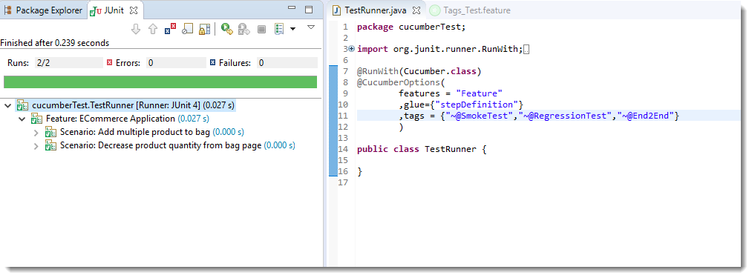

What are Hooks in Cucumber?
Cucumber supports hooks, which are blocks of code that run before or after each scenario. You can define them anywhere in your project or step definition layers, using the methods @Before and @After. Cucumber Hooks allows us to better manage the code workflow and helps us to reduce the code redundancy. We can say that it is an unseen step, which allows us to perform our scenarios or tests.

Why Cucumber Hooks?
In the world of testing, you must have encountered the situations where you need to perform the prerequisite steps before testing any test scenario. This prerequisite can be anything from:
- Starting a webdriver
- Setting up DB connections
- Setting up test data
- Setting up browser cookies
- Navigating to certain page
- or anything before the test
In the same way, there are always after steps as well of the tests like:
- Killing the webdriver
- Closing DB connections
- Clearing the test data
- Clearing browser cookies
- Logging out from the application
- Printing reports or logs
- Taking screenshots on error
- or anything after the test

Hook Demo:

Feature: Test Hooks

Scenario: This scenario is to test hooks functionality
Given this is the first step
When this is the second step
Then this is the third step

package stepDefinition;

import cucumber.api.java.en.Given;
import cucumber.api.java.en.Then;
import cucumber.api.java.en.When;

public class Hooks_Steps {

@Given("^this is the first step$")
public void This_Is_The_First_Step(){
System.out.println("This is the first step");
}

@When("^this is the second step$")
public void This_Is_The_Second_Step(){
System.out.println("This is the second step");
}

@Then("^this is the third step$")
public void This_Is_The_Third_Step(){
System.out.println("This is the third step");
}

}

package utilities;
import cucumber.api.java.After;
import cucumber.api.java.Before;

public class Hooks {

@Before
public void beforeScenario(){
System.out.println("This will run before the Scenario");
}

@After
public void afterScenario(){
System.out.println("This will run after the Scenario");
}
}

Demo2: with multiple scenario:

Tagged Hooks in Cucumber
Feature: Test Tagged Hooks

@First
Scenario: This is First Scenario
Given this is the first step
When this is the second step
Then this is the third step

@Second
Scenario: This is Second Scenario
Given this is the first step
When this is the second step
Then this is the third step

@Third
Scenario: This is Third Scenario
Given this is the first step
When this is the second step
Then this is the third step
Step Definitions
package stepDefinition;

import cucumber.api.java.en.Given;
import cucumber.api.java.en.Then;
import cucumber.api.java.en.When;

public class Hooks_Steps {

@Given("^this is the first step$")
public void This_Is_The_First_Step(){
System.out.println("This is the first step");
}

@When("^this is the second step$")
public void This_Is_The_Second_Step(){
System.out.println("This is the second step");
}

@Then("^this is the third step$")
public void This_Is_The_Third_Step(){
System.out.println("This is the third step");
}

}

Hooks
package utilities;

import cucumber.api.java.After;
import cucumber.api.java.Before;

public class Hooks {

@Before
public void beforeScenario(){
System.out.println("This will run before the every Scenario");
}

@After
public void afterScenario(){
System.out.println("This will run after the every Scenario");
}

@Before("@First")
public void beforeFirst(){
System.out.println("This will run only before the First Scenario");
}

@Before("@Second")
public void beforeSecond(){
System.out.println("This will run only before the Second Scenario");
}

@Before("@Third")
public void beforeThird(){
System.out.println("This will run only before the Third Scenario");
}

@After("@First")
public void afterFirst(){
System.out.println("This will run only after the First Scenario");
}

@After("@Second")
public void afterSecond(){
System.out.println("This will run only after the Second Scenario");
}

@After("@Third")
public void afterThird(){
System.out.println("This will run only after the Third Scenario");
}
}

Common Tagged Hooks for Multiple Scenarios
We can have common tagged hooks for multiple scenarios as well. In the below example, I just combined the @Before(“First”) and @Before(“Third”) by @Before(“@First, @Third”). So in this way we do not need to have two different hooks logic.

Order:
Feature: Test Order Hooks

Scenario: First scenario to test Order Hooks functionality
Given this is the first step
When this is the second step
Then this is the third step

Scenario: Second scenario to test Order Hooks functionality
Given this is the first step
When this is the second step
Then this is the third step

Step:
package stepDefinition;
import cucumber.api.java.en.Given;
import cucumber.api.java.en.Then;
import cucumber.api.java.en.When;

public class Hooks_Steps {
@Given("^this is the first step$")
public void This_Is_The_First_Step(){
System.out.println("This is the first step");
}
@When("^this is the second step$")
public void This_Is_The_Second_Step(){
System.out.println("This is the second step");
}
@Then("^this is the third step$")
public void This_Is_The_Third_Step(){
System.out.println("This is the third step");
}
}
Hooks:
package stepDefinition;
import cucumber.api.java.en.Given;
import cucumber.api.java.en.Then;
import cucumber.api.java.en.When;

public class Hooks_Steps {
@Given("^this is the first step$")
public void This_Is_The_First_Step(){
System.out.println("This is the first step");
}
@When("^this is the second step$")
public void This_Is_The_Second_Step(){
System.out.println("This is the second step");
}
@Then("^this is the third step$")
public void This_Is_The_Third_Step(){
System.out.println("This is the third step");
}
}

